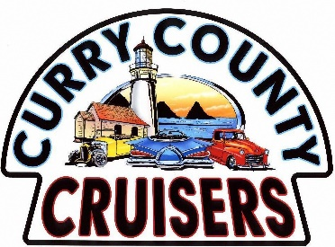
P.O. Box 1863, Brookings, OR 97415; E-Mail: currycruisers@gmail.com; Phone: 530-739-9717
Visit our website at: www.currycountycruisers.com

30th ANNUAL CAR SHOW -- SUNDAY MAY 26, 2024
SPONSORSHIP REQUEST FORM
Since 2010, the Curry County Cruisers car club has donated well over $84,500.00 to local Charities and Non-Profits in the Brookings-Harbor area (see back for details). With your support, we can continue to give back to our community. Our events bring in hundreds of people from outside the local area, and many of them spend the entire weekend here, enjoying the Brookings-Harbor area supporting our local economy.
We would like to ask you for your support by sponsoring our Annual Car Show and fundraising event.
Sponsorship Levels
Titanium Sponsor $1,200.00 Name on all 23 First place awards & CCC Show Banner.
Diamond Sponsor $1000.00 Name on all 23 Second place awards & CCC Show Banner.
Opal Sponsor $1000.00 Name on all 6 Specialty Plaques & CCC Show Banner
(Two Best of Shows, Best Interior, Best Paint, Best Engine, Bob Johnson Award and Participation)
All sponsors will be announced during the show.
Payment Deadline for Titanium, Diamond and Opal is April 15th, 2024, to have your name on awards.

Thank you for your Sponsorship Donation of: $
Would you like to donate a Raffle Prize or Auction Item for the event? Y________ N_______
Company Name:

Contact Person: Phone:

Thank you for your generosity and your support in our community fundraising.

Curry County Cruiser Member ___________________________________________

Curry County Cruisers Annual Benefit Car Show
Total Cash Donations for 2023--$14,000 THANK YOU TO ALL OF OUR SPONSORS!

Donation List from 2023
- American Music Festival (Summer concerts at Azalea Park)
- Brookings Harbor Community Helpers (Food Bank)
- Curry Community Cares
- Brookings Harbor High School (Safe and Sober Graduation)
- I love 4th of July—Brookings Fireworks
- Natures Coastal Holiday (Christmas Lights at Azalea Park)
- Northwest American Indian Coalition (NAIC)
- Oasis Advocacy and Shelter
- Safety City
- South Coast Humane Society
- Chetco Senior Center and Meals on Wheels
- CASA
- Cape Ferrelo Fire District
- Harbor Fire District
- Winchuck Fire District
- St. Timothy’s Food Service
- Star of the Sea Catholic Church Food Service
- Trinity Lutheran Food Service
- Brookings Presbyterian
- Brookings-Harbor Educational Foundation
- Local VFW

Additional Sponsorship Opportunities
- Silent Auction Items: Acknowledged on CCC Show Banner and announced during the show.
- Raffle Prizes: Announced during the show.
- Display your company banner on the announcer’s trailer:
Contact Lori Connelly: Cell: 530.739.9717 or email connellyt@sisqtel.net

