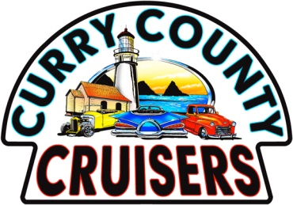
PO B0X 1863 Brookings, OR. 97415 E-Mail: currycruisers@gmail.com Website: currycountycruisers.com
MEMBERSHIP APPLICATION

Name: ________________________________________________________________________

Address: ______________________________________________________________________

City: State: Zip:

Phone: Cell:

E-Mail:

Birth Date: Month: Day: Marital Status: Single: ( ) Married: ( )

Spouse’s Name: _______________________________ Birthday: Month_______ Day_______

Spouse’s E-Mail:

Do you own an antique, classic or collectible vehicle? Yes ( ) No ( )

Year: _______ Make: Model:

Year: Make: Model:

Other Car Club (s) Membership? ___________________________________________________

Sponsored by: __________________________________________________________________

I agree to abide by the By-Laws of the Curry County Cruisers car club. Accepted: ( )

Signature: _________________________________________ Date: _____________________

Annual Dues: $30.00. Please make checks payable to: Curry County Cruisers

