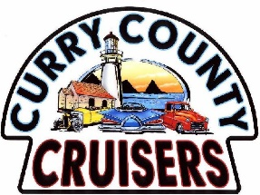November Curry County Cruiser Meeting
Sunday, November 12th Happy Thanksgiving!
1-1:30 Members meet and greet at the clubhouse.
Heron Ridge Apts. 521 Fir St. (East on Oak off 101, then R on Fir St)
1:30 Meeting called to order.
Old Business: Ronnie: Review of October minutes Motion/discussion/vote
New Business:
- Ronnie: November Birthdays Informational
- Roger: Financial and Membership report Motion/discussion/vote
- Donation Request—Brookings Harbor Educational Foundation Motion/discussion/vote
Other donation suggestion Motion/discussion/vote
- Pint Glass order decisions (Glasses due in December) Motion/discussion/vote
- Membership Christmas Dinner Old Hoodies/sweatshirts ’22 Informational
Car show member cars New T-shirts and Hats
Please visit www.currycountycruisers.com
- Sponsors update Informational
- Dates for Natures Coastal Holiday workers and sign-up sheets Informational
- Changes to the committee and board descriptions Informational October 2024, and a new board will be voted in….
The Finale: 50-50 Draw
Pick up of Food Bank Items—Ken Thank you all for donating!
Next Member meeting & Christmas Dinner Party planned for Tuesday, December 5th.
Chetco Activity Center,550 Chetco Lane (behind Subway) Meet/greet/music at 4:30, dinner by 5:30.
Parking available for self-contained motorhomes for a one night stay over. Limited space.
BYOB, Bring a gift for the gift exchange game, Call with questions: 530-739-9717
Order online before Nov. 21st: www.currycountycruisers.com
May 26, 2024— 30th Annual Curry County Cruiser Car Show 6 months away

