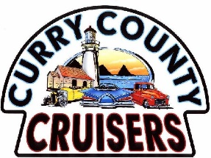January Curry County Cruiser Meeting
Sunday, January 14th Happy New Year
1-1:30 Members meet and greet at the clubhouse.
Heron Ridge Apts. 521 Fir St. (East on Oak off 101, then R on Fir St)
1:30 Meeting called to order.
Old Business: Ronnie: Review of December minutes Motion/discussion/vote
New Business:
- Ronnie: January Birthdays Informational
- Roger: Financial and Membership report Motion/discussion/vote
- Additions to Committees: Lori Informational
- Sponsor Report: Lori Informational
- Car Show Flyer Presentation Informational
- Coordinators Report Informational
Planning needs & and giving thanks.
- Club Dues are due this month (please)

The Finale: 50-50 Draw
Pick up of Food Bank Items—Ken Thank you for donating!
Next Member meeting planned for Sunday, **February 18th. Same place, same time
**Third Sunday to skip Super Bowl Sunday on the 11th.
Car Show, Here We Go!
May 26, 2024— 30th Annual Curry County Cruiser Car Show 4 ½ months away

